1. Download and instal MongoDB 64-bit. Do a screen print showing the successful installation of MondoDB.

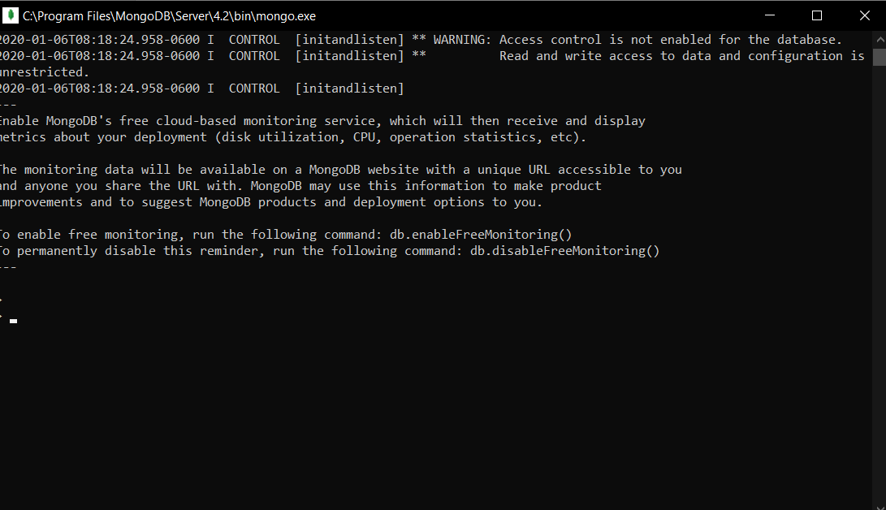

1. Download and install MongoDB Compass. Do a screen print showing the successful installation of MongoDB Compass.

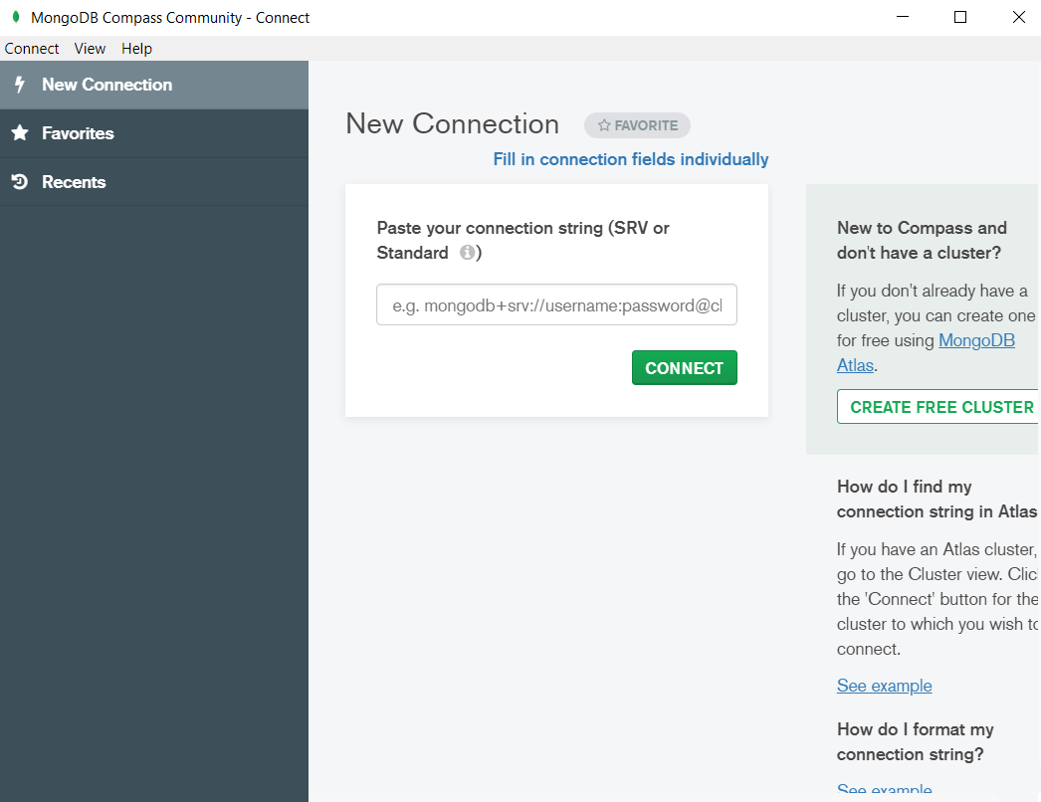

1. Do a screen print showing the sample Books data (step 7 of Configure MongoDB).

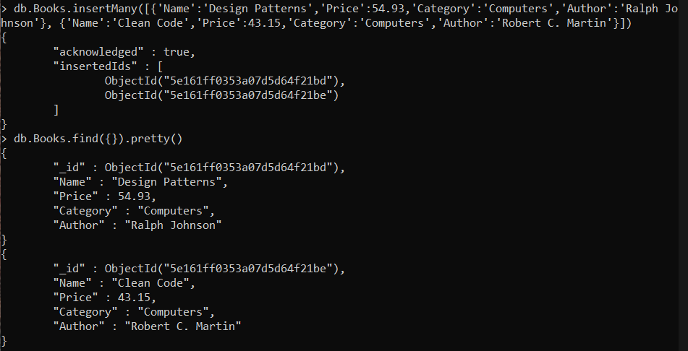

1. Launch MongoDB Compass and Connect (default settings should work just fine). Do a screen print showing the list of current databases (BookstoreDb should be one of tehm).

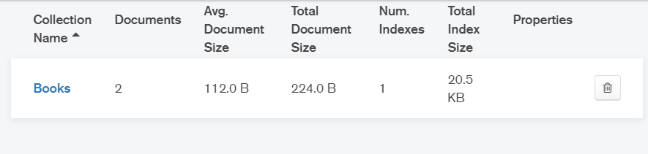

1. Drill down into the BookstoreDb until the data is shown, and do a screen print of List mode and Table mode both.

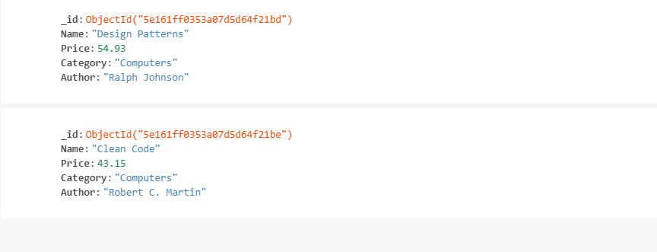

1. After creating the new project, use Package Manager to install the latest MongoDB driver. Do a screen print of Package Manager showing it was installed.

